A202-Afr-Egy- Ushabti-New Kingdom Period-18th dynasty (1549/1550-1292 BCE)

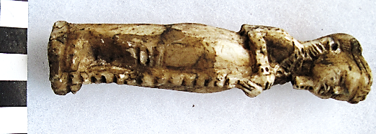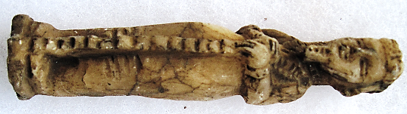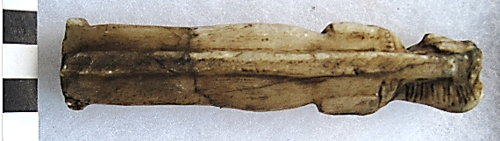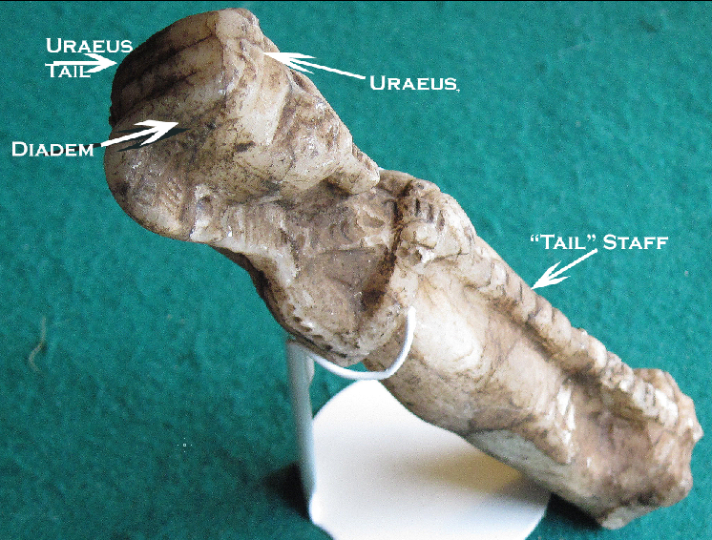

**Case No.: 2**

**Formal Label:** Egyptian Ushabti-New Kingdom Period-18th dynasty (1549/1550-1292 BCE)

**Display Description:** Second Int. Period Ushabtis had the hands on top of the mummy wrappings, usually holding sacred symbols. This Ushabti probably dates just after the Second Int. Period to the early Eighteenth Dynasty, possibly in the reign of Tutankhamun (1332-1323 BCE). In this Ushabti the object being held by the deceased resembles that which was buried with Tutankhamun, what Howard Carter described as a gold and lapis lazuli “tail” backed by a gold plate. Howard Carter noted: “16 Jan-1 May [1923] spent cleaning restoring & recording objects found on King's Mummy Object 256 EEE Tail found below legs of mummy” (**From http://www.griffith.ox.ac.uk).**

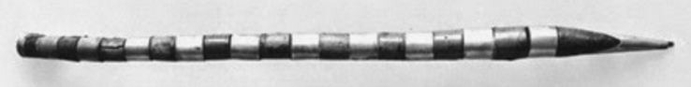

Fig. gold and lapis lazuli “tail” staff possibly symbolizing the Uraeus. **From http://www.griffith.ox.ac.uk/gri/taa_i_2_10.html**

**This gold and lapis lazuli “Tail” was perhaps the tail of a decapitated cobra so that it could not prove dangerous to the deceased but still retained its power. Ritual objects that were deemed too dangerous were ritually “discharged”. This object was obviously used for a ritual purpose to signify** Tutankhamun’s **royal authority.**

The second surprise in this Ushabti is the headgear that also resembles what Harold Carter found when he began uncovering the linen from Tutankhamun’s head: an unusual crown (From http://www.griffith.ox.ac.uk/gri/taa_i_2_10.html:

“(4N) Some of the outer bandages of the top of the head, remained adhering to the interior of the mask, thus exposing a double rope-like 'lawaya' encircling the crown of the head, made of a (?) fibrous material tightly bound with string. This had slipped down slightly during the operation of withdrawing the head from mask. This peculiar object has loops at the back for attachment and being of very fragile nature it was somewhat broken. Over the left orbit, possibly originally attached to 4N, though this is not clear, there were six dark blue faience beads. …”

Then Howard Carter described the figure of Tutankhamun’s “magnificent diadem, in the form of a gold fillet encrusted, having two back and two side appendages.” “Beneath (4N) there were several layers of wrappings, of coarse linen probably for protective reasons, which when removed disclosed around the crown of the head a magnificent diadem, in the form of a gold fillet encrusted, having two back and two side appendages. The side appendages have uraeii attached to them.”

[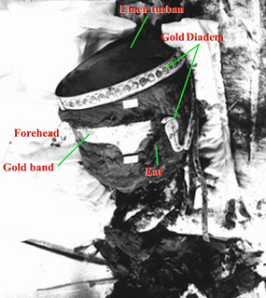](http://3.bp.blogspot.com/-Jr0pkwEmzOk/UWlQlYEwDoI/AAAAAAAAAJo/TbcMUxfboQg/s1600/The+head.jpg)

Fig. The unwrapping of the head with the diadem in place, from http://www.griffith.ox.ac.uk.

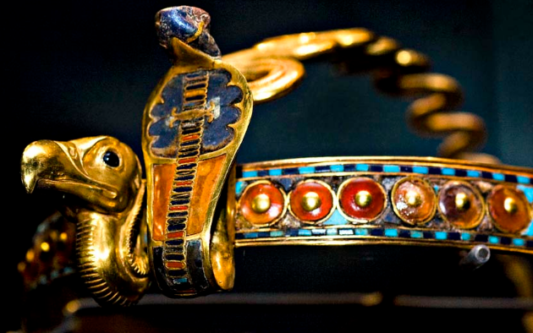 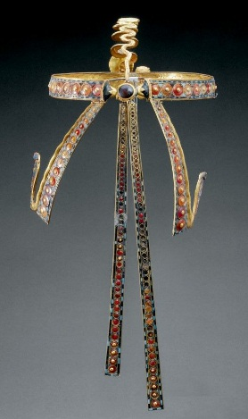

#### Left: Fig. Front view of Diadem of Tutankhamun with Vulture and Cobra: Gold, glass, obsidian, carnelian, malachite, chalcedony, lapis lazuli (1332–1323 BCE) tomb of Tutankhamun, Valley of the Kings, Thebes. Note the vertical lozenges on the vulture’s throat and on the cobra’s ventral side. From https://encrypted-tbn0.gstatic.com Middle: Fig. ¾ left side view of Diadem of Tutankhamun. From http://imgur.com. Right: Fig. Rear view of Diadem of Tutankhamun. From <https://s-media-cache-ak0.pinimg.com>

#### 

#### Fig. The Egyptian cobra. From <https://isiopolis.files.wordpress.com/2014/08/egyptian-cobra.jpg>

#### The Egyptian cobra was used as the model for the Uraeus has horizontal lozenges along its ventral side. Uraeus is from the Greek οὐραῖος, ouraîos, "on its tail"; from Egyptian jʿr.t (iaret), "rearing cobra") is the stylized, upright form of the Egyptian cobra, used as a symbol of sovereignty, royalty, deity and divine authority. The Uraeus is a symbol for the goddess Wadjet, one of the earliest of Egyptian deities, who often was depicted as a cobra.

**Accession Number: A202**

**LC Classification:** DT62

**Date or Time Horizon:** New Kingdom Period-18th dynasty (1549/1550-1292 BCE)

**Geographical Area: KV62 Valley of the Kings**

**Map, GPS Coordinates:** 25.74036 32.60141; 25º44'25.29" N 32º36'5.06" E

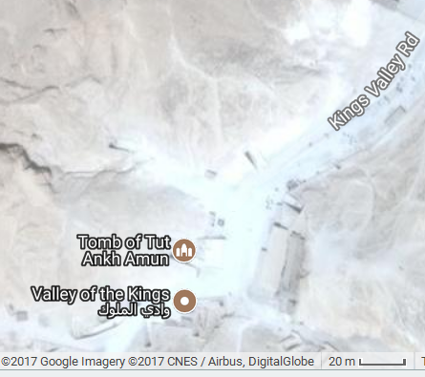 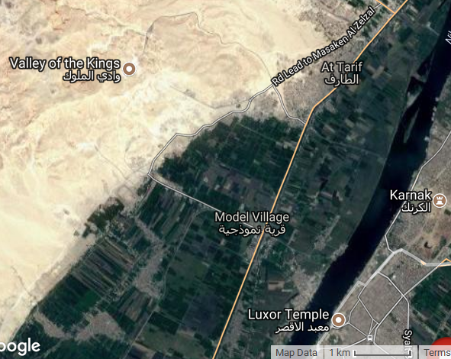

**Cultural Affiliation:** New Kingdom Period

**Medium:** chlorite

**Dimensions: H 130.5 mm; 5.139 in  
Weight: 128 gm; 4.5 oz**

**Provenance: European collection.**

**Condition: original, right side of headdress is missing.**

**Discussion: The following notes accompanied Howard Carter’s uncovering the “tail” object.**

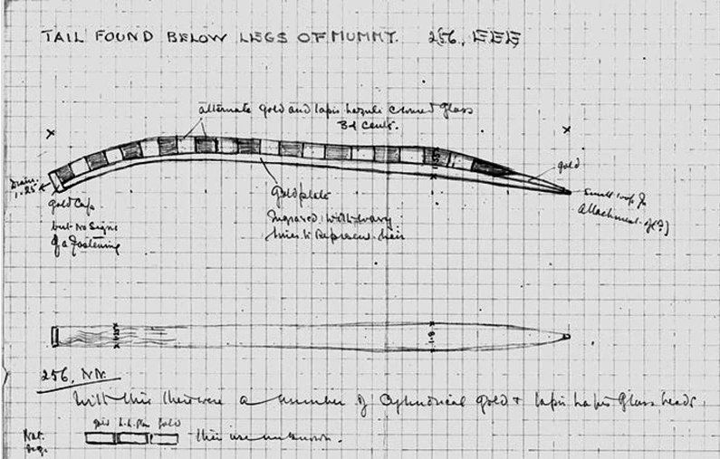

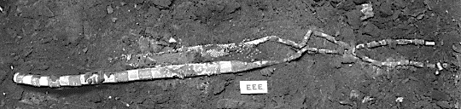

**From** From http://www.griffith.ox.ac.uk/gri/taa_i_2_10.html.

**References**